BAV MAGAZINE SPECTROSCOPY
20XX No. X ISSN XXXX-XXXX
Bundesdeutsche Arbeitsgemeinschaft für Veränderliche Sterne e.V.
http://bav-astro.de
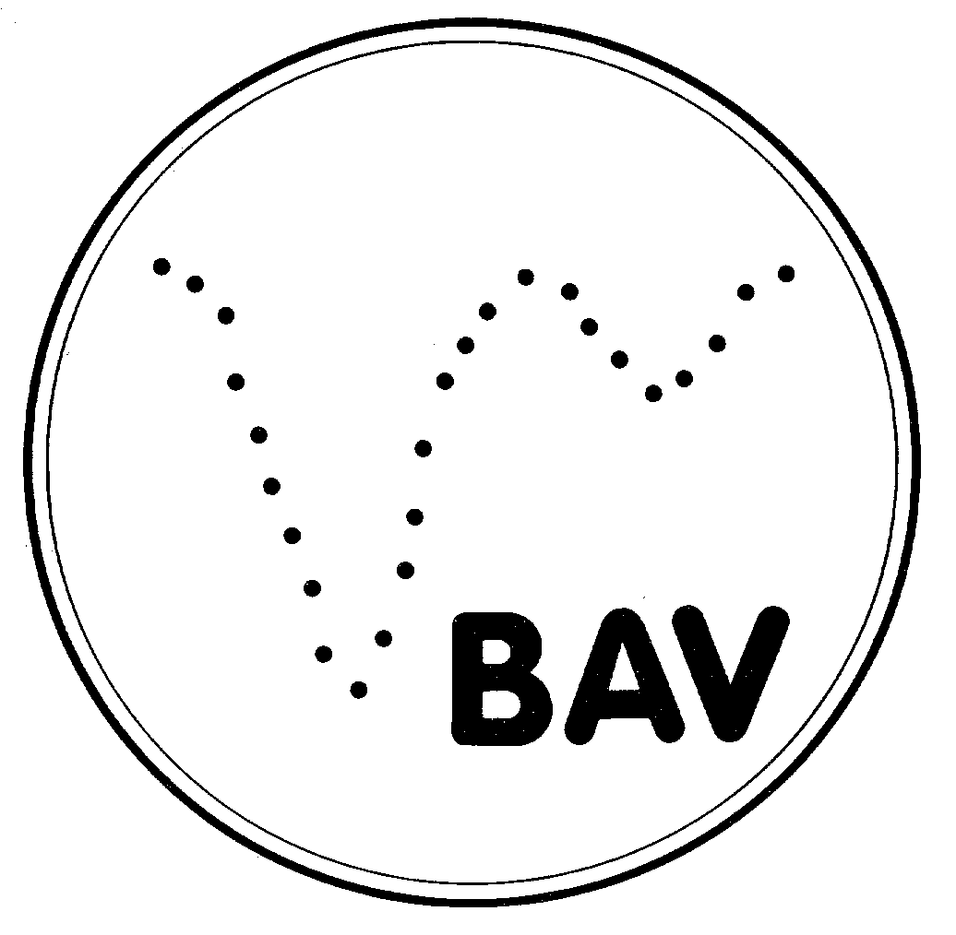
AAVSO-BAV-ARAS Campaign: Photometry and Spectroscopy of P Cygni
Cyclic Variation (Period 310 day) of the intrinsic Hα line flux
Intermediate Report 2016

Ernst Pollmann
Emil-Nolde-Str. 12, 51375 Leverkusen, ernestospec@hotmail.de…
May, 2016
Abstract
With the combined campaign of the Luminous Blue Variable star P Cyg, we are trying for the first time by way of simultaneous measurements of photometrical V brightness and Hα equivalent width (EW), to realize a long-term monitoring of the intrinsic Hα line flux. To find out if and how the flux obtained from the spectral line profiles varies, the EW measurements is corrected for the effect of variation of the continuum flux. The photometrical observers of the AAVSO, observer of the BAV and spectroscopical observer of the ARAS group started this campaign in November 2008 in order to continue former investigations [1] & [2], whose results are based on multi-daily averaging of Vmag and EW. We receive with our data a reliable reference of a clear dominant period of 310 day of the intrinsic flux of the Hα emission.

Intermediate Report 2016
The current state of our campaign enables with all our collected data of the Hα equivalent width (shown in Fig. 1) & the phototmetrical Vmag (shown in Fig. 2) to try a period analysis of the intrinsic Hα line flux, the primary aim of this campaign
(http://astrospectroscopy.de/media/files/PCYG_AAVSO.pdf). The intrinsic Hα line flux (ordinate of Fig. 3) was calculated by division of the Hα equivalent width by the simultaneous photometric Vmag data of different observers.
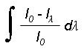
From the definitions of EW =

and the relation between stellar magnitudes and continuum flux variations F2 / F1 = 10^{-0.4 (m2-m1)} it follows, that the line flux is F = C x EW / 10 ^{(0.4 Vphot).} The derived quantity is then not the line flux in physical units, but a quantity proportional to the physical line flux, corrected for continuum variations.

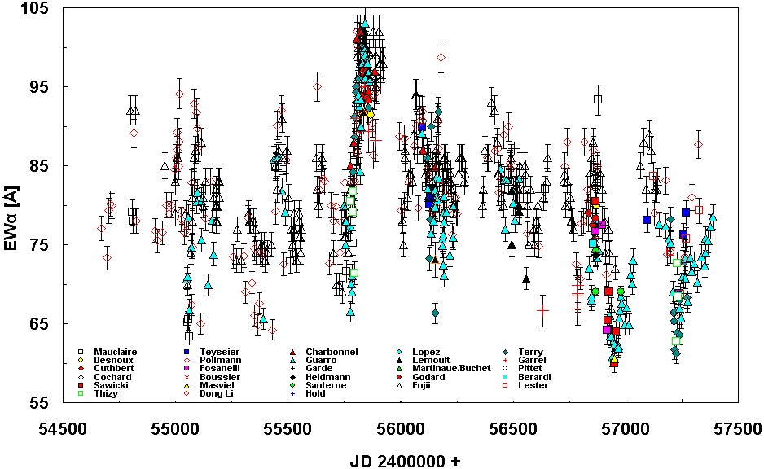

Fig. 1: Long-term monitoring of the Hα equivalent width of P Cyg in collaboration with different observers of the ARAS group

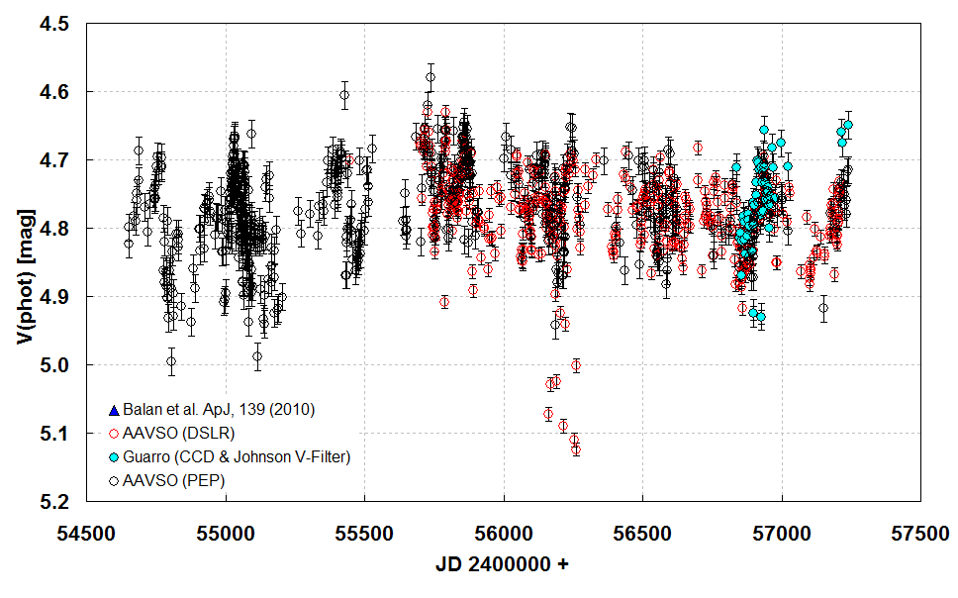

Fig. 2: Long-term monitoring of the photometrical Vmag of the AAVSO data base [photo electric photometry (PEP) & DSLR], J. Guarro (ARAS, CCD & Jonson Filter) and [3]

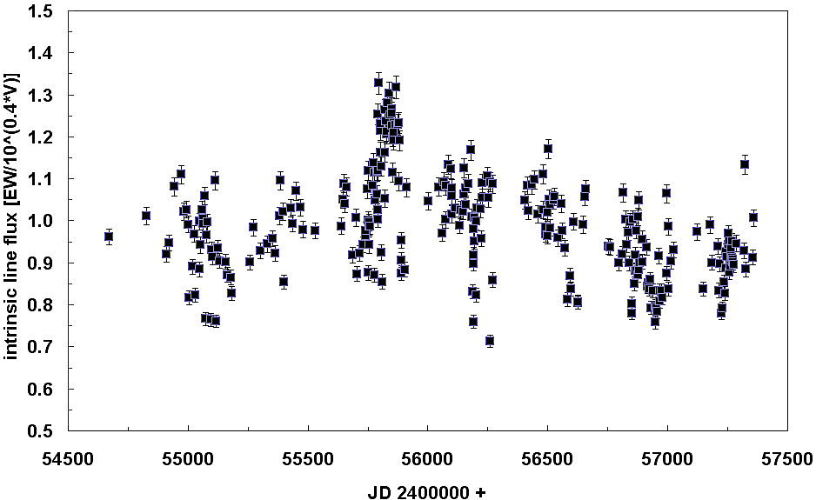

Fig. 3: Long-term monitoring of the intrinsic Hα line flux

With consideration of the standard deviation and possibly other kinds of errors, the temporal variation of the line flux of Hα in the plot of Fig.3 will represent the result of variations in the mass loss rate, stellar wind density, and changes of the ionization from JD 2454671 (23 July 2008) through JD 2457387 (30. December 2015). The usage of the period search program “AVE software, Analisis de Variabilidad Estelar” Version 2.51;
(http://www.astrogea.org/soft/ave/introave.htm) in Fig. 4 enables to perform the main aim of the campaign, to find out periodicities of the Hα line flux.

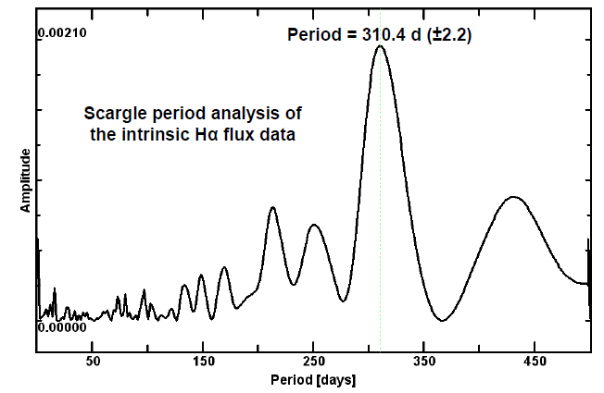

Fig. 4: Scargle period analysis performed with the program AVE of the Hα line flux data in Fig. 3

Earlier results of the investigation period 2008 to 2013 (170 spectra & Vmag) published in [4] shows in the so-called “Scargle power spectrum” periods of 242 days, 363 days and 600 days, with a dominant period at 242 days. The current data set with 270 spectra & Vmag data represents now a more extended investigation period from 2008 to 2015 and gives with the dominant period of 310.4 (± 2.2) days a much greater degree of confidence.

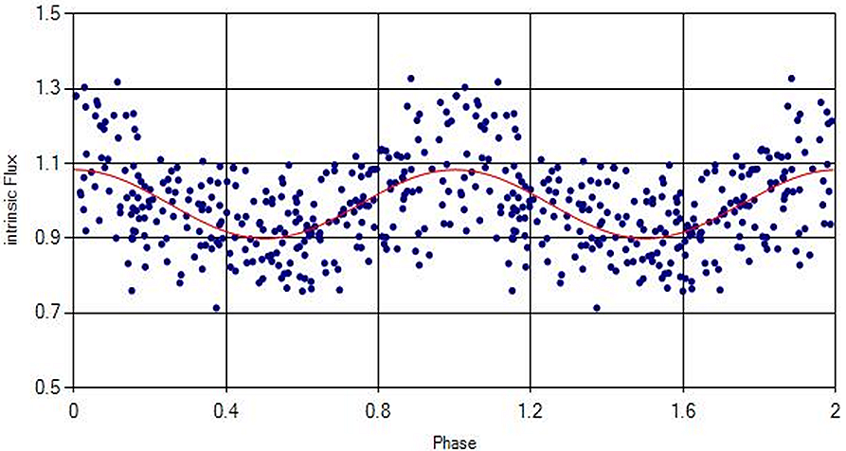

Fig. 5: Phase diagram of the 310.4 day period of Fig. 4

Summary
The intrinsic Hα line flux data shown in Fig. 3 enable the period analysis shown in Fig. 4. The Scargle-diagram shows a clear dominant period of 310.4 day. The phase diagram of that period is shown in Fig. 5. The dispersion of the line flux (ordinate) in Fig. 5 results mainly from spectroscopic EW measurements (accuracy +/- 2%) and the photometrical Vmag measurements (accuracy +/- 0.001 – 0.003 mag). For the first time we receive with our data a reliable reference of the periodic character of the intrinsic flux of the Hα emission (see intermediate report 2014: http://www.astrospectroscopy.de/media/files/PCyg_report_2014.pdf). It will be of high interest to see, how the found period can be improved with further data within the next years.

Acknowledgements
I am grateful to the observers of the AAVSO (http://www.aavso.org/data-download), BAV (http://www.bav-astro.eu/joomla/index.php/beobachtungspraxis/spektroskopie/kampagnen) and the ARAS group (http://www.astrosurf.com/aras)

References
[1] Markova, N., Morrison, N., Kolka, I., and Markov, H. 2001a, A&A, 376, 898.

[2] Markova, N., Scuderi, S., de Groot, M., Markov, H., and Panagia, N. 2001b, A&A, 366, 935.

[3] Balan, A., Tycner, C., Zavala, R. T., Benson, J. A., Hutte, D. J., Templeton, M., 2010: The Astronomical Journal, 139, 2269-2278 : The spartially resolved Halpha emitting wind structure of P Cygni
[4] Pollmann, E. & Vollmann, W., 2013 JAAVSO Volume 41,24:
Intermediate Report on January 2013 Campaign: Photometry and Spectroscopy of P Cygni

